QUICK SORT USING PIVOT AS AVERAGE

Contribution: 1. Om Vijay Mundlik 2. Pratap Sunil Gore 3. Om Anil Gore
First year Computer Engineering Diploma
^{Roll No.: 2255,2237,2263}

Abstract—
"Quick Sort Using Pivot as the Average" is a novel sorting algorithm that optimizes the selection of the pivot element by taking the average of all elements in the array. This innovative approach ensures a balanced partitioning of the data, reducing the likelihood of worst-case scenarios, and improving overall sorting efficiency. The algorithm's performance is analysed and compared to traditional Quick Sort methods, demonstrating its enhanced speed and reliability. By employing this technique, Quick Sort becomes more predictable and robust in various applications, making it a valuable addition to the arsenal of sorting algorithms. Overall, this report provides a comprehensive overview of BCI technology, its current state, and its potential applications. It highlights the opportunities and challenges associated with BCI technology and its potential to transform the way we interact with machines and the world around us.
- Introduction
Sorting is a fundamental operation in computer science, with a wide range of applications across various domains. Quick Sort is one of the most efficient and widely-used sorting algorithms, known for its impressive average and best-case time complexity. One crucial aspect of Quick Sort is the selection of a pivot element, which significantly influences its performance. While many pivot selection methods exist, using the average of all array elements as the pivot is an intriguing approach that aims to improve the algorithm's efficiency further.
The Quick Sort algorithm, developed by Tony Hoare in 1960, operates on the principle of divide and conquer. It partitions an array into two subarrays and recursively sorts them. The choice of the pivot, around which elements are partitioned, plays a vital role in the algorithm's efficiency. Traditionally, the pivot is selected as the first, last, or middle element of the array. However, this can lead to suboptimal performance, particularly when the input data is already partially sorted or contains duplicates.
Using the average of all array elements as the pivot seeks to mitigate these issues. This method calculates the average of all values in the array and selects the result as the pivot element. By doing so, Quick Sort aims to balance the partitions, reducing the chances of creating skewed subarrays that could lead to suboptimal time complexity. This approach is especially useful when sorting datasets with unpredictable distribution and minimizes the worst-case scenario, resulting in more consistent and efficient sorting.
In this article, we will delve into the concept of using the average of all array elements as the pivot in Quick Sort, exploring its implementation and analysing its impact on the algorithm's performance.
- What is Quick sort using pivot as AVERAGE?

Before understanding the Quick sort using pivot as average, we have to understand how the traditional quick sort algorithm work. The Quick sort using pivot as Average is a modification of the traditional quick sort The traditional Quick Sort algorithm works on Divide and concur method. The traditional quick sort makes a partition in the original array with the help of pivot element. The original array in divided into two subarray one is greater than pivot element and another one is lesser than pivot element. This process happens recursively. The pivot selection the controversial topic where it is on the programmer. When we select the first or the last element as pivot it creates an unbalanced partition of the array. Here when we choose the pivot element as average (here the average refers to the average of the all elements present in the array) or the element nearest to average, it gives us a balanced partition of the element. The main motive of this algorithm is that to provide a balanced partition with sorted output.
Average element

AVG= (7+2+3+4+0)/5= 3 (floor)
2
3
4
0
7

- Working of Quick sort using pivot as AVERAGE

Working of Quick sort using pivot as AVERAGE is same as the traditional quick sort algorithm but the modification is that we set the average element as the pivot element.
Let us firstly understand the working of the traditional quick sort algorithm with an example.

Let us consider an array A with size 7.
0 1 2 3 4 5 6
2
3
9
5
7
4
6
A=

Suppose Pivot= A [0], i= A [0] & j= A [6]
0 1 2 3 4 5 6
2
3
9
5
7
4
6

i
j

Here comes the condition that increment pointer i till i<=Pivot
And decrement pointer j till j>Pivot

0 1 2 3 4 5 6
2
3
9
5
7
4
6

i
j

If the i<j then swap A[i] and A[j]

0 1 2 3 4 5 6
2
3
6
5
7
4
9

i
j

Re-increment and decrement pointer i & j respectively from previous position with same condition.
0 1 2 3 4 5 6
2
3
6
5
7
4
9

i
j

If i>j then swaps pivot and A [j]
Left Subarray
Right Subarray

0 1 2 3 4 5 6
2
3
6
5
4
7
9

i
j

Here the position of the pivot element is gotten fixed.
Means the original array is get divided into two subarrays.

- Right Sub-array: - Elements> pivot
- Left Sub-array: - Elements < pivot

Same process happens for the subarray

2
3
6
5
4
7
9
Round 1:

2
4
5
6
3
7
9
Round 2:

3
4
5
6
2
7
9
Round 3:

Sorted Output

We get a basic idea about How the Quick Sort Works. This is about the traditional quick sort algorithm. Let us see how our algorithm works. simply there is minor difference in it.

Let us consider the same array of this algorithm.
2
3
9
5
7
4
6
A=
0 1 2 3 4 5 6

Taking average of the all elements

Average element

0 1 2 3 4 5 6
2
3
9
5
7
4
6

AVG= (7+2+3+9+5+4+6)/7= 5 (floor)

Swapping Average element and A [0]
2
3
9
7
5
4
6
0 1 2 3 4 5 6

Set Pivot= A [0], i= A [0] & j= A [6]
i
j
2
3
9
7
5
4
6
0 1 2 3 4 5 6

Here comes the condition that increment pointer i till i<=Pivot
And decrement pointer j till j>Pivot

0 1 2 3 4 5 6
2
3
9
7
5
4
6

i
j

If the i<j then swap A[i] and A[j]

0 1 2 3 4 5 6
2
3
4
7
5
9
6

i
j

Re-increment and decrement pointer i & j respectively from previous position with same condition.
0 1 2 3 4 5 6
2
3
4
7
5
9
6

i
j

If i>j then swaps pivot and A [j]
Left Subarray
Right Subarray

0 1 2 3 4 5 6
2
3
5
7
4
9
6]6

i
j

Here the position of the pivot element is gotten fixed.
Means the original array is get divided into two subarrays.

- Right Sub-array: - Elements> pivot
- Left Sub-array: - Elements < pivot

But here our algorithm works it divides the array in a balanced manner. Here the pivot element has 3 elements on the both sides.

Same process happens for the subarray

2
3
5
7
4
9
6
Round 1:

2
4
5
7
3
9
6
Round 2:

3
4
5
6
2
7
9
Round 3:

Sorted Output

Now, you can understand that how the Quick sort using pivot as AVERAGE works. Let we find complexity and main difference between it.

- Complexity of Algorithm

- Time Complexity:

- Worst Case: The worst-case time complexity of Quick Sort occurs when the partitioning is highly unbalanced, meaning one partition has all the elements, and the other is empty. In the given code, the pivot selection is based on the average of the elements, but there is no guarantee that the pivot will always result in balanced partitions. In the worst case, the partitioning process needs to iterate over all the elements for each recursive call. This gives a time complexity of O(n^2).

- Average Case: On average, Quick Sort has a time complexity of O(n log n). However, the specific approach used in this code for selecting the pivot (taking the average and finding the nearest elements) might affect the average-case behaviour. The average-case analysis for this modified version is complex and may vary based on the input distribution.
- Best Case: The best-case time complexity of Quick Sort occurs when the partitions are balanced, meaning the pivot divides the array into roughly equal halves. In the best-case scenario, each partitioning step divides the array into two halves, leading to a total time complexity of O (n log n).

Here in our algorithm, there are some extra steps needed that’s why the complexity of the program gets increases.

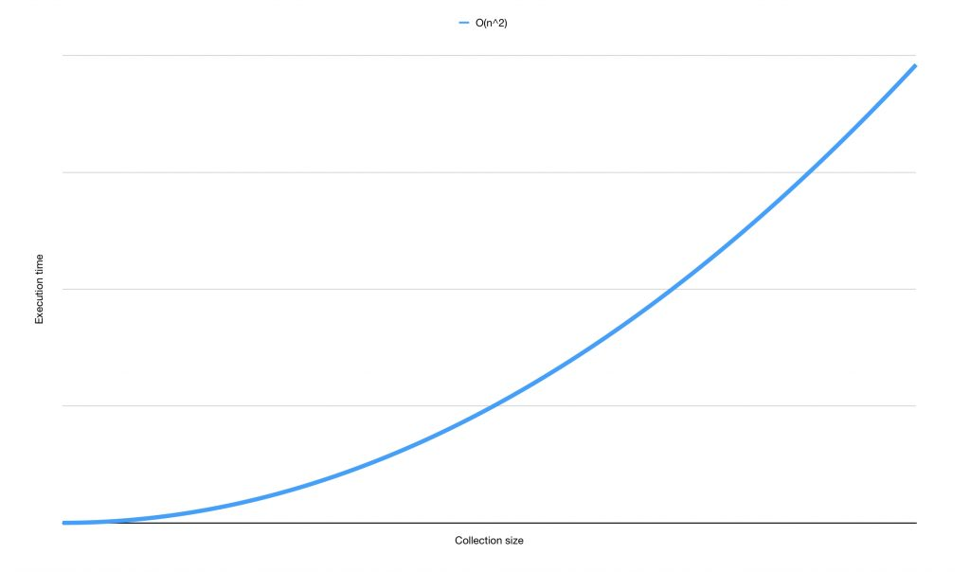

Worst Case Time Complexity

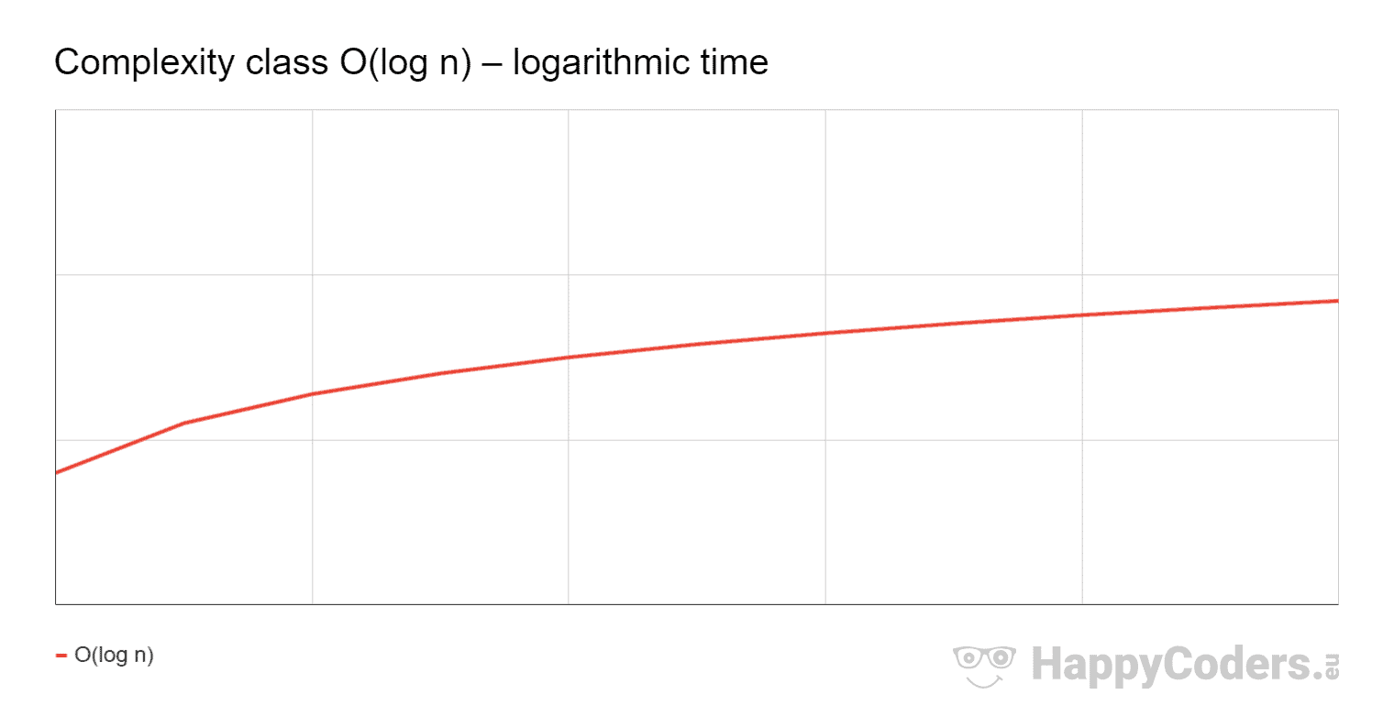

Average Case & Best Time Complexity

- Algorithm

- Code of the algorithm

#include<stdio.h>
#include<conio.h>
void quick (int [], int,int);
int main ()
{
int a [10], i,j,n,low,high,mid,sum=0,t;
clrscr();

//Information
printf("__________________________________________
________________________________");

printf("\n\t\t\tQUICK SORT USING PIVOT=AVG\n\nProject by: 1.Om Vijay Mundlik\t2.Pratap Sunil Gore\t3.Om Anil Munde\n");
printf ("\nRules: -\n1.Size is the number of elements that you want to enter.\n2.Enter element one by one by adding space. after reaching size press enter.\n3.Sorting is done on the elements as per size.");

printf("\n__________________________________________________________________________");

// Size entering

printf ("\n\nEnter the size (MAX 10): \t");
scanf ("%d”, &n);

// Array elements entering

printf ("Enter array elements:\t");
for (i=0; i<n; i++)
{
scanf("%d",&a[i]);
}

// initialization

low=0;
high=n-1;

//Taking AVG

for (i=0; i<n; i++)
{
sum=sum+a[i];
}
mid=sum/n;

//Comparing elements with AVG

for (i=0; i<n; i++)
{
if(a[i]==mid) //Condition 1: mid or AVG element is present in array.
{
t=a[low]; //Swapping AVG element and element present at low
a[low]=a[i];
a[i]=t;
}

for(j=1;j<20;j++)

if((a[i]==mid+j) || (a[i]==mid-j)) //Condition 2: Nearest element is present.
{
t=a[low]; //Swapping nearest AVG element and element present at low
a[low]=a[i];
a[i]=t;
}

else
{
break;
}

}

//function call

quick(a,low,high);

//sorted output

printf("\nArray after sorting:");
for(i=0;i<n;i++)
{
printf("\t%d",a[i]);
}

printf("\n__________________________________________________________________________");

getch();
return 0;
}

void quick (int a [], int low, int high)
{
int pivot,i,j,t;
if(low<high)
{
pivot=a[low];
i=low+1;
j=high;

while(1)
{

while(a[i]<pivot && i<=high) //searching greater element
{
i++;
}
while(a[j]>pivot && j>= low) //searching lower element
{
j--;
}
if(i<j) //swapping greater and lower element after searching operation
{
t=a[i];
a[i]=a[j];
a[j]=t;
}
else
{
break;
}
}
a[low]=a[j]; //updating low & pivot element
a[j]=pivot;
quick(a,low,j-1); //calling for left sub array
quick(a,j+1,high); //calling for right sub array
}
}

- Result of program

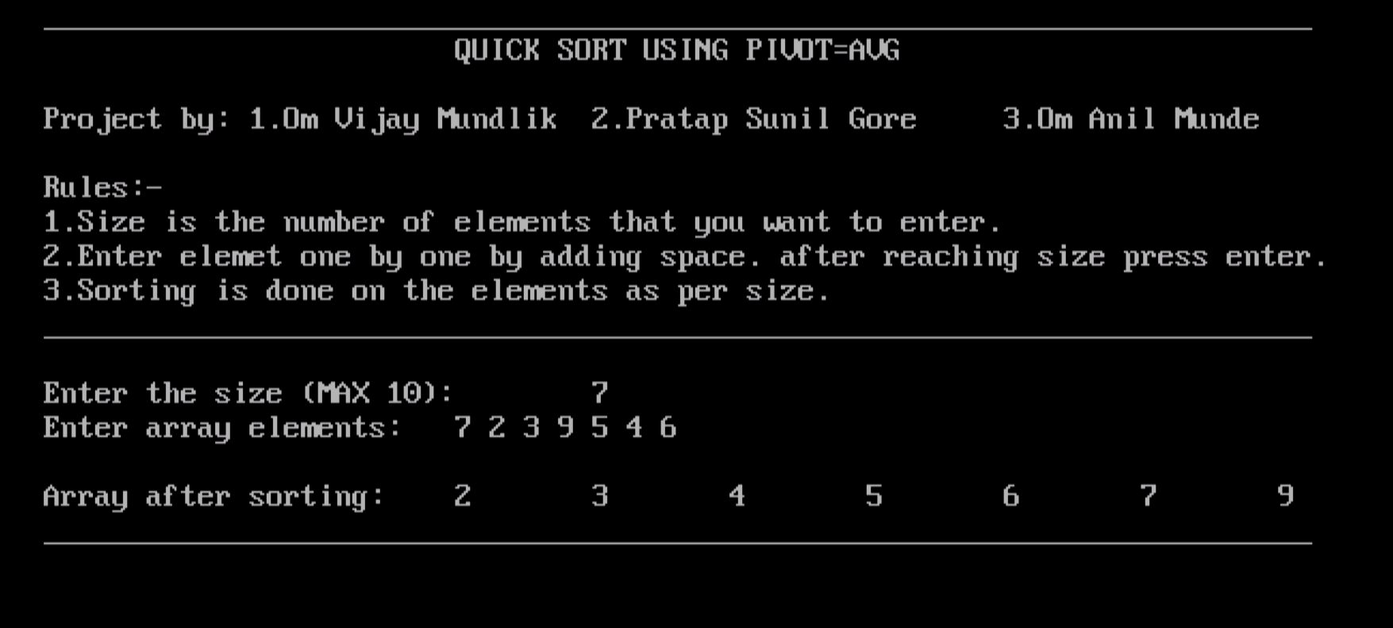
Input: A [7] = {7,2,3,9,5,4,6}

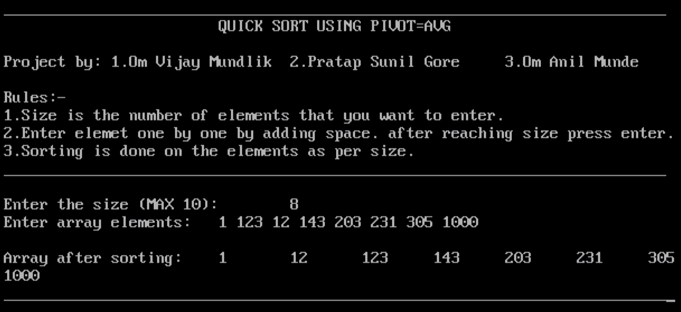
Input: A [8] = {1,123,12,143,203,231,305,1000}
.
- Conclusion

In conclusion, The Quick Sort using Pivot as Average is a great option when we consider a set of small database. Because the Time Complexity of program is O(n²) which is higher than the traditional algorithm.It works similar to the traditional quick sort algorithm there is a different step to consider the element same as average of array element or nearest to it as Pivot. It is good for represtation of quick sort because it gives us Balanced and sorted output. Overall the performance of algorithm is good in best condition.

- Acknowledgment

We would like to give our sincere gratitude to Mr. S.S. Joshi Sir who give us motivation and support to report. And the well contribution of team members in this important is really great. A really great thanks all the person who directly or indirectly help us doing the report.

- Reference

https://www.google.com/search?q=O(n+log+n)+time+complexity+graph&tbm=isch&ved=2ahUKEwisn-GivPuBAxVSSmwGHQoICRQQ2-cCegQIABAA&oq=O(n+log+n)+time+complexity+graph&gs_lcp=CgNpbWcQAzoECCMQJ1DtCVjtCWDaF2gAcAB4AIAB1QGIAZkDkgEFMC4xLjGYAQCgAQGqAQtnd3Mtd2l6LWltZ8ABAQ&sclient=img&ei=naUtZezcJdKUseMPipCkoAE&bih=707&biw=1536&rlz=1C1ONGR_enIN1071IN1071#imgrc=fSXjlZqzyMDNwM
https://www.google.com/search?q=o(n%5E2)+time+complexity+graph&sca_esv=573847129&rlz=1C1ONGR_enIN1071IN1071&tbm=isch&sxsrf=AM9HkKknbqtT3Ou_Mc1gznvjs66ei3RrMw:1697490330798&source=lnms&sa=X&ved=2ahUKEwiU3rShvPuBAxWr3jgGHfkEBFoQ_AUoAXoECAIQAw&biw=1536&bih=707&dpr=1.25#imgrc=PgG2D-5JPChbbM&imgdii=L-Aho3g1PGJLFM

https://www.researchgate.net/publication/225961350_Algorithms/link/0046352536c2c89203000000/download
https://chat.openai.com/

https://www.youtube.com/shorts/W4MSynGX5ws?feature=share

***

